Summary card — Topic 5: Two Draws Without Replacement
Statistics · Midterm Team Project: Joint Distributions
1. Model | Topic 5 — Two draws without replacement. Urn with N balls, K red. X₁, X₂ = 1 if the 1st / 2nd ball is red, else 0. p = K/N, q = 1 − p.
2. Joint pmf and support | Support {0,1}² (a rectangle). N(N−1) equally likely ordered pairs.  p(1,1) = K(K−1)/[N(N−1)] p(1,0) = p(0,1) = K(N−K)/[N(N−1)] p(0,0) = (N−K)(N−K−1)/[N(N−1)]  Valid: all ≥ 0 and the sum = [K(K−1) + 2K(N−K) + (N−K)(N−K−1)] / [N(N−1)] = 1.
3. Marginals | Sum the joint pmf: P(X₁=1) = P(X₂=1) = K/N, so X₁, X₂ ~ Bernoulli(p). The 2nd ball has the same marginal as the 1st although the draws are dependent.
4. Conditionals | P(X₂=1 | X₁=1) = (K−1)/(N−1) P(X₂=1 | X₁=0) = K/(N−1) (K−1)/(N−1) < K/N < K/(N−1)  Same formulas for X₁ given X₂ (the joint pmf is symmetric).
5. E, Var, Cov, ρ | E(Xᵢ) = p; Var(Xᵢ) = pq; E(X₁X₂) = p(1,1) = K(K−1)/[N(N−1)]  Cov(X₁,X₂) = −K(N−K) / [N²(N−1)] = −pq/(N−1) ρ = −1/(N−1) (does not depend on K)  Negative: a red first ball removes one red ball. ρ → 0 when N → ∞. E(X₂ | X₁=x) = (K−x)/(N−1).
6. Independence | Criterion: p(x₁,x₂) = p(x₁)p(x₂) for all cells and a rectangular support. At (1,1): p(1,1) − (K/N)² = −K(N−K)/[N²(N−1)] ≠ 0, so dependent (for 0<K<N). But exchangeable: p(1,0) = p(0,1), i.e. p(x₁,x₂) = p(x₂,x₁).
7. Sum S = X₁ + X₂ | S ~ Hypergeometric(N, K, 2): P(S=s) = C(K,s)·C(N−K,2−s) / C(N,2), s = 0, 1, 2 (P₀ = (N−K)(N−K−1)/[N(N−1)], P₁ = 2K(N−K)/[N(N−1)], P₂ = K(K−1)/[N(N−1)]).  E(S) = 2p; Var(S) = 2pq − 2pq/(N−1) = 2pq(N−2)/(N−1) — equals n·pq·(N−n)/(N−1) with n = 2.
8. Main Part D result | For n draws, Sₙ = I₁+…+Iₙ, Cov(Iᵢ,Iⱼ) = −pq/(N−1) for each of the n(n−1)/2 pairs, so  Var(Sₙ) = npq · (N−n)/(N−1) (finite-population correction). Check: n = N gives 0. With replacement Var = npq. If N → ∞ and K/N → p, Hypergeometric(N,K,n) → Binomial(n, p).
9. Picture | 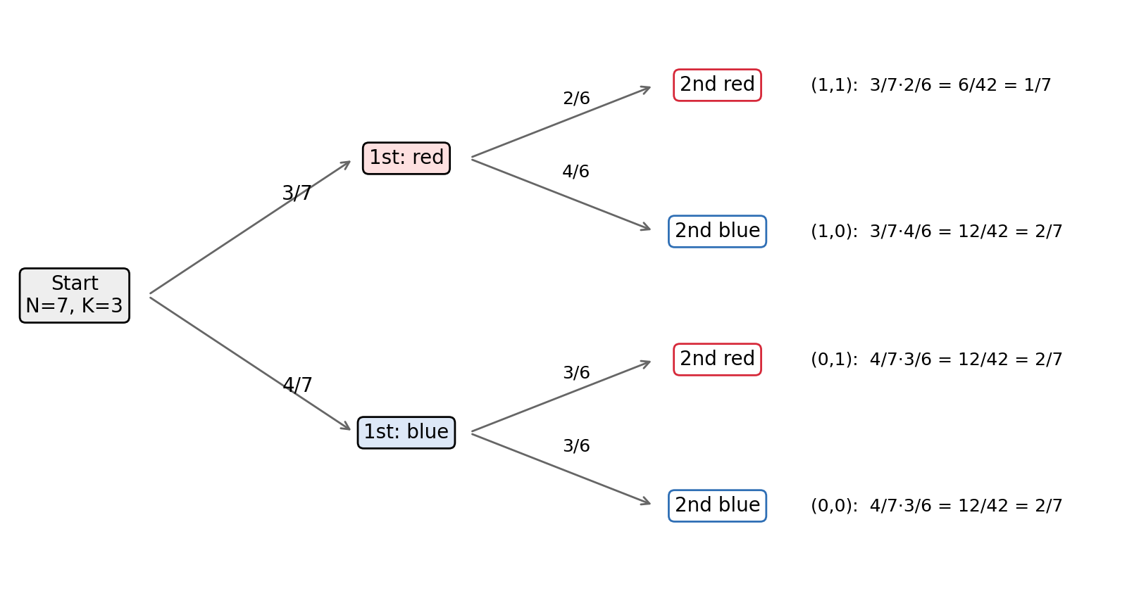  Probability tree for N = 7, K = 3: p(1,1) = 1/7, the other three cells = 2/7.
10. Real example | Inspect 2 of 10 chargers, 3 defective: P(both defective) = (3/10)(2/9) = 1/15 ≈ 0.067; P(at least one defective) = 8/15 ≈ 0.533.

